**Task 2**

**Description**

This task required a multi-threaded approach to count frequency of words in a text file, the file was divided into N segments, each assigned to a different thread to utilize parallel processing. The main thread waits for all the worker threads to finish then combines the result into a final frequency-count, this makes the program much more efficient since it’s using parallel programming.

**Code**

#include <stdio.h>  
#include <stdlib.h>  
#include <string.h>  
#include <pthread.h>  
#include <ctype.h>  
  
#define MAX_WORDS 1000  
#define MAX_WORD_LEN 100  
  
typedef struct {  
    char word[MAX_WORD_LEN];  
    int count;  
} WordFreq;  
  
typedef struct {  
    char *segment;  
    int segment_size;  
    WordFreq *word_freq;  
    int word_count;  
} ThreadData;  
  
void *count_word_frequency(void *arg) {  
    ThreadData *data = (ThreadData *)arg;  
    char *segment = data->segment;  
    int segment_size = data->segment_size;  
    WordFreq *word_freq = data->word_freq;  
    int *word_count = &data->word_count;  
  
    char word[MAX_WORD_LEN];  
    int word_len = 0;  
  
    for (int i = 0; i < segment_size; i++) {  
        if (isalpha(segment[i]) || segment[i] == '\'') {  
            word[word_len++] = tolower(segment[i]);  
        } else if (word_len > 0) {  
            word[word_len] = '\0';  
            word_len = 0;  
  
            int found = 0;  
            for (int j = 0; j < *word_count; j++) {  
                if (strcmp(word_freq[j].word, word) == 0) {  
                    word_freq[j].count++;  
                    found = 1;  
                    break;  
                }  
            }  
  
            if (!found) {  
                strcpy(word_freq[*word_count].word, word);  
                word_freq[*word_count].count = 1;  
                (*word_count)++;  
            }  
        }  
    }  
  
    if (word_len > 0) {  
        word[word_len] = '\0';  
  
        int found = 0;  
        for (int j = 0; j < *word_count; j++) {  
            if (strcmp(word_freq[j].word, word) == 0) {  
                word_freq[j].count++;  
                found = 1;  
                break;  
            }  
        }  
  
        if (!found) {  
            strcpy(word_freq[*word_count].word, word);  
            word_freq[*word_count].count = 1;  
            (*word_count)++;  
        }  
    }  
  
    pthread_exit(NULL);  
}  
  
void merge_word_frequencies(WordFreq *final_freq, int *final_count, WordFreq *thread_freq, int thread_count) {  
    for (int i = 0; i < thread_count; i++) {  
        int found = 0;  
        for (int j = 0; j < *final_count; j++) {  
            if (strcmp(final_freq[j].word, thread_freq[i].word) == 0) {  
                final_freq[j].count += thread_freq[i].count;  
                found = 1;  
                break;  
            }  
        }  
        if (!found) {  
            strcpy(final_freq[*final_count].word, thread_freq[i].word);  
            final_freq[*final_count].count = thread_freq[i].count;  
            (*final_count)++;  
        }  
    }  
}  
  
int find_word_boundary(char *text, int position, int max_size) {  
    for (int i = position; i < max_size; i++) {  
        if (isspace(text[i]) || text[i] == '\0') {  
            return i + 1;  
        }  
    }  
    return max_size;  
}  
  
int main(int argc, char *argv[]) {  
    if (argc != 3) {  
        fprintf(stderr, "Usage: %s <filename> <N>\n", argv[0]);  
        exit(EXIT_FAILURE);  
    }  
  
    char *filename = argv[1];  
    int N = atoi(argv[2]);  
  
    FILE *file = fopen(filename, "r");  
    if (!file) {  
        perror("Failed to open file");  
        exit(EXIT_FAILURE);  
    }  
  
    fseek(file, 0, SEEK_END);  
    long file_size = ftell(file);  
    fseek(file, 0, SEEK_SET);  
  
    char *file_content = (char *)malloc(file_size + 1);  
    fread(file_content, 1, file_size, file);  
    file_content[file_size] = '\0';  
    fclose(file);  
  
    pthread_t threads[N];  
    ThreadData thread_data[N];  
    WordFreq final_freq[MAX_WORDS];  
    int final_count = 0;  
  
    int segment_size = file_size / N;  
    int start = 0;  
  
    for (int i = 0; i < N; i++) {  
        int end = (i == N - 1) ? file_size : find_word_boundary(file_content, start + segment_size, file_size);  
  
        thread_data[i].segment = file_content + start;  
        thread_data[i].segment_size = end - start;  
        thread_data[i].word_freq = (WordFreq *)malloc(MAX_WORDS * sizeof(WordFreq));  
        thread_data[i].word_count = 0;  
  
        pthread_create(&threads[i], NULL, count_word_frequency, &thread_data[i]);  
        start = end;  
    }  
  
    for (int i = 0; i < N; i++) {  
        pthread_join(threads[i], NULL);  
    }  
  
    for (int i = 0; i < N; i++) {  
        merge_word_frequencies(final_freq, &final_count, thread_data[i].word_freq, thread_data[i].word_count);  
        free(thread_data[i].word_freq);  
    }  
  
    for (int i = 0; i < final_count; i++) {  
        printf("%s: %d\n", final_freq[i].word, final_freq[i].count);  
    }  
  
    free(file_content);  
  
    return 0;  
}

**Figures**

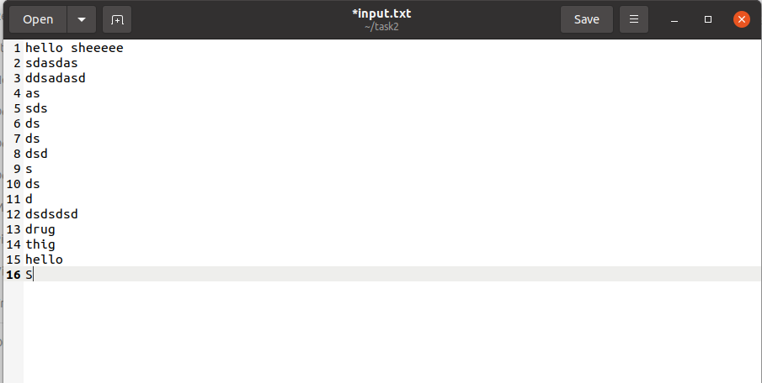

**Github link**

[**https://github.com/FirasAhmed2/Operating-systems-coursework.git**](https://github.com/FirasAhmed2/Operating-systems-coursework.git)